Financing Government
Directions:
- This lesson consists of 2 assignments. Total point value is 50 points.
- Complete the lesson reading “Economics” before doing the assignments.

- The 2 assignments for this lesson are
  - Reading Questions – 25 points
  - Political Cartoon - 25 points
Total – 50 points
Send all assignments together at the same time.

Type all your answers in blue below the assignment. Be sure to save your work as you complete the assignment!

Assignment 1 – Reading Questions
5 points each

1. State three reasons why our government expenses have grown since Washington’s first budget.

- Increasing expectations

- Growing Population

- Increased National Defense Spending

2. Personal income tax is a progressive tax. What does this mean and why is it fair?

a. What is meant?
The tax is based upon a person’s income, a higher income will result in a higher tax.

b. Fair?
This is fair because the poor have to pay less money, and the rich have the money to spend on taxes.

3. What is your opinion of the government taxing harmful or undesirable products (example – cigarettes or alcohol)?

I think it is just, it allows the government to control harmful products. This gives the government the power to filter products from our economy.

4. Explain federal deficit spending and one possible consequence.

Explanation
Deficit spending, or borrowing money to make income match expenses, has doubled and quadrupled this debt in recent years.

Consequence

Borrowing will hurt future generations who will have no choice but to pay back the public debt of the past.

5. What three important programs do social insurance taxes pay for?

- Social Security

- Medicaid

c. Veteran Benefits

Assignment 2 – Political Cartoon
5 pts each

Study the cartoon and answer the questions

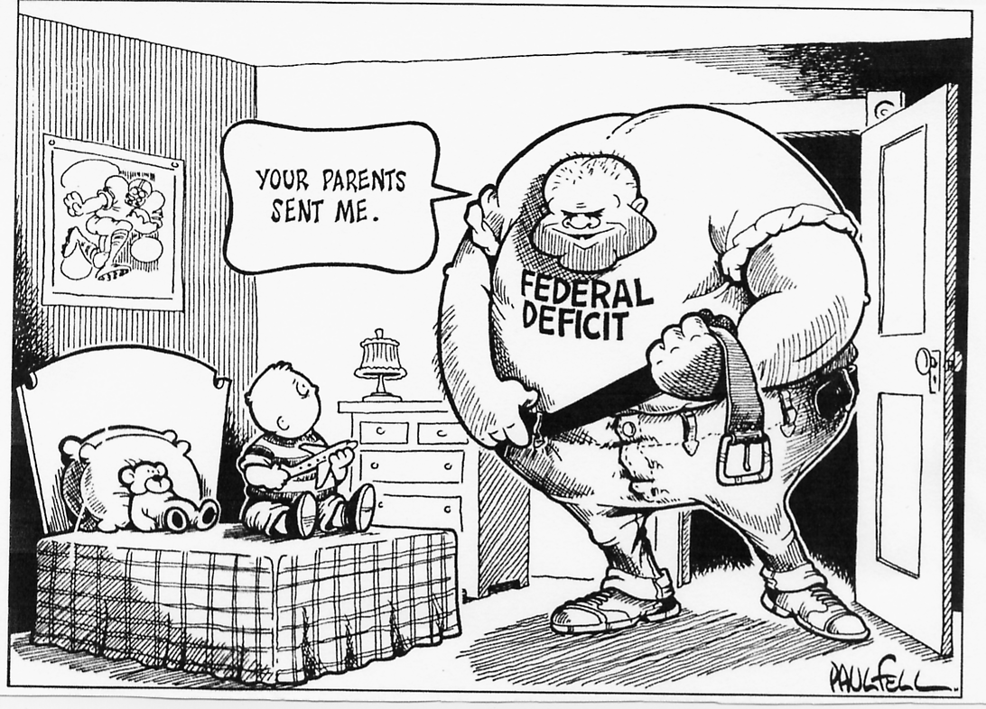

1. Who are the people represented in the cartoon?

a. child represents -

Future generations

- Bully – represents
Our nation’s debt

2. What topic is shown in the cartoon?

Our nations economy

3. What is the artist’s feeling on this issue?

That we are setting up future generations for an economic crisis.

4. Name five clues in the cartoon that tell the cartoon’s meaning?

- Bully

- The bully is big, representing a big amount of money

- Kid represents future generations

- The kid is small, representing a small amount of money

- Bully says “Your parents sent me” blaming our current generation for our future national debt.

5. Why is the topic in the cartoon important?

Because we can’t just keep borrowing money forever, one day our debt will be so incomprehensible that future generations will never be able to afford to fund the government.

